
ISSUE: 25
QUARTERLY NEWSLETTER

The Daniels Decision and the “Other Métis”
“
.”

News From The Of ce
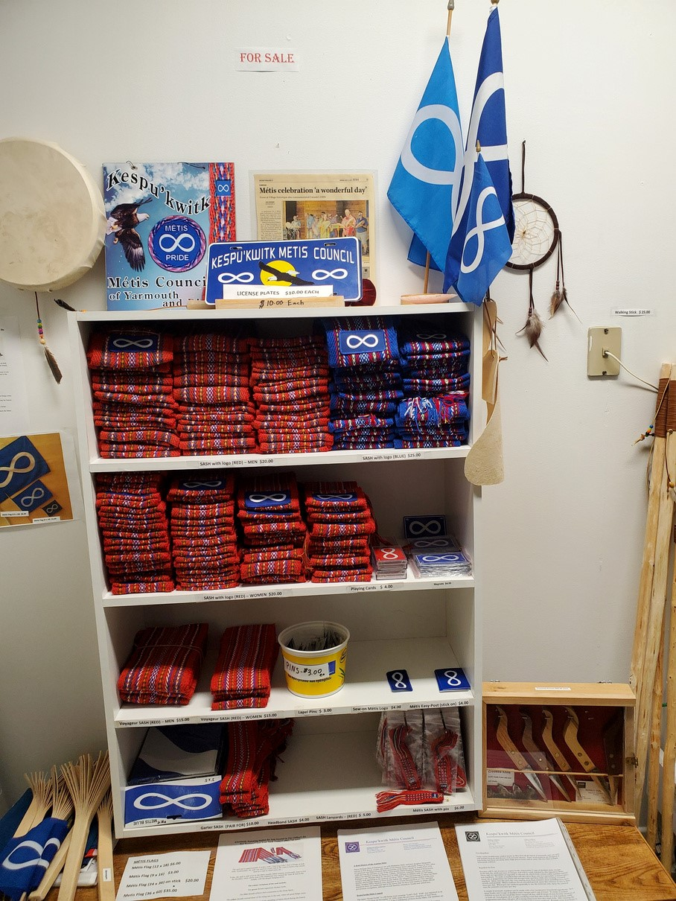
Sashes, Flags, and More for Sale!


Recent and Upcoming Events
Watch this space for a link to the upcoming new KMC website!

Contact Info
Of ce Administrator Phone Email

